 | DEPARTMENT OF COMPUTER ENGINEERING
Experiment No. 4A
Semester | T.E. Semester VI
Subject | ARTIFICIAL INTELLIGENCE (CSL 604)
Subject Professor In-charge | Prof. Avinash Shrivas
Assisting Teachers | Prof. Avinash Shrivas

Student Name | Deep Salunkhe
Roll Number | 21102A0014
Lab Number | 310A

Title:

8 Puzzle Problem
Theory:

- Problem Description: Start with a description of the problem you implemented, which is the 8-puzzle problem. Explain how the 8-puzzle problem involves a 3x3 grid where eight numbered tiles are placed and one blank space is available for movement.

- Heuristic Functions: Discuss heuristic functions used in the A* search algorithm. Explain how the Manhattan distance heuristic calculates the distance between each tile's current position and its goal position. This heuristic helps estimate the minimum number of moves required to reach the goal state.

Program Code:
#include<iostream>
#include<vector>
#include<math.h>
using namespace std;

void ISGS(vector<vector<int> >&IS,vector<vector<int> >&GS){
cout<<"NOTE: To enter blank use 0"<<endl;
cout<<"Pls enter the Goal state"<<endl;
for(int i=0;i<3;i++){
for(int j=0;j<3;j++){
cin>>GS[i][j];
}
}

cout<<"Pls enter the Initial state"<<endl;
for(int i=0;i<3;i++){
for(int j=0;j<3;j++){
cin>>IS[i][j];
}
}

}

void display2d(vector<vector<int> >v){
for(int i=0;i<3;i++){
for(int j=0;j<3;j++){
cout<<v[i][j]<<" ";
}
cout<<endl;
}
}

bool goalReached(vector<vector<int> >&IS,vector<vector<int> >&GS){
for(int i=0;i<3;i++){
for(int j=0;j<3;j++){
if(IS[i][j]!=GS[i][j])
return false;
}

}

return true;
}

void moveUp(vector<vector<int> >&IS,vector<vector<int> >&GS){

int xb;
int yb;

for(int i=0;i<3;i++){
for(int j=0;j<3;j++){
if(IS[i][j]==0){
//cout<<"Deep Salunkhe"<<endl;
xb=i;
yb=j;
}
}
}

if(xb==0)
cout<<"Cant go any up"<<endl;
else{
swap(IS[xb][yb],IS[xb-1][yb]);
}

}

void moveRight(vector<vector<int> >&IS,vector<vector<int> >&GS){

int xb;
int yb;

for(int i=0;i<3;i++){
for(int j=0;j<3;j++){
if(IS[i][j]==0){
xb=i;
yb=j;
}
}
}

if(yb==2)
cout<<"Cant go any right"<<endl;
else{
swap(IS[xb][yb],IS[xb][yb+1]);
}

}
void moveDown(vector<vector<int> >&IS,vector<vector<int> >&GS){

int xb;
int yb;

for(int i=0;i<3;i++){
for(int j=0;j<3;j++){
if(IS[i][j]==0){
xb=i;
yb=j;
}
}
}

if(xb==2)
cout<<"Cant go any Down"<<endl;
else{
swap(IS[xb][yb],IS[xb+1][yb]);
}

}
void moveLeft(vector<vector<int> >&IS,vector<vector<int> >&GS){

int xb;
int yb;

for(int i=0;i<3;i++){
for(int j=0;j<3;j++){
if(IS[i][j]==0){
xb=i;
yb=j;
}
}
}

if(yb==0)
cout<<"Cant go any Left"<<endl;
else{
swap(IS[xb][yb],IS[xb][yb-1]);
}

}

int heuristic(vector<vector<int> >&IS,vector<vector<int> >&GS){
int value=0;
for(int i=0;i<3;i++){
for(int j=0;j<3;j++){
int curr_ele=IS[i][j];
int cex=i;
int cey=j;
int fx;
int fy;
if(curr_ele==0)
continue;
for(int x=0;x<3;x++){
for(int y=0;y<3;y++){
if(GS[x][y]==curr_ele){
value=value+abs(cex-x)+abs(cey-y);
}
}
}
}
}

return value;
}

int main(){
vector<vector<int> >IS(3,vector<int>(3,0));
vector<vector<int> >GS(3,vector<int>(3,0));
ISGS(IS,GS);

while(!goalReached(IS,GS)){
cout<<"Goal State is"<<endl;
display2d(GS);
cout<<"Current State is"<<endl;
display2d(IS);
int hvalue=heuristic(IS,GS);
cout<<"heuristic value :"<<hvalue<<endl;

cout<<"What should we do with the blank(-1)"<<endl;
cout<<"1. Move UP"<<endl;
cout<<"2. Move RIGHT"<<endl;
cout<<"3. Move DOWN"<<endl;
cout<<"4. Move LEFT"<<endl;

int choice;
cin>>choice;
switch(choice){
case 1: moveUp(IS,GS);
break;
case 2: moveRight(IS,GS);
break;
case 3: moveDown(IS,GS);
break;
case 4: moveLeft(IS,GS);
break;
default:cout<<"Invalid choice"<<endl;
}

if(!goalReached(IS,GS)){
cout<<"Goal State is"<<endl;
display2d(GS);
cout<<"Current State is"<<endl;
display2d(IS);
int hvalue=heuristic(IS,GS);
cout<<"heuristic value :"<<hvalue<<endl;
}

}

cout<<"You have completed task"<<endl;

return 0;
}

Output:

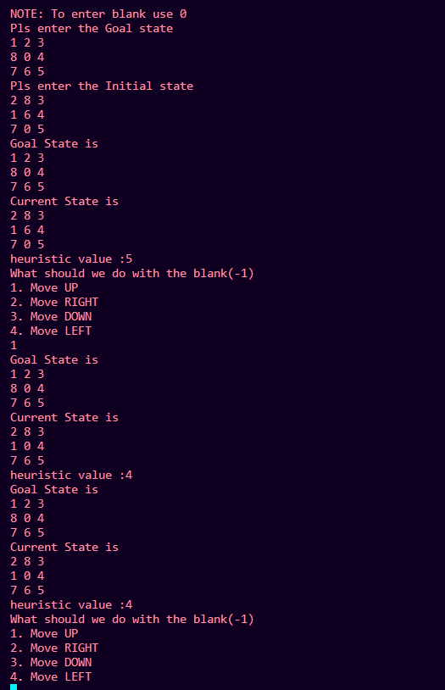

Conclusion:

In this lab exercise, we addressed the 8-puzzle problem using heuristic search techniques. We employed the Manhattan distance heuristic to estimate the distance between the current state and the goal state. This heuristic provided valuable guidance in selecting the next move, significantly reducing the search space and improving the efficiency of the search algorithm.
Through this practical session, we observed the effectiveness of heuristic functions in guiding the search towards the goal state efficiently. By estimating the minimum number of moves required to reach the goal state, the Manhattan distance heuristic facilitated the discovery of optimal solutions.
Furthermore, the implementation demonstrated the practical applications of heuristic search techniques in solving real-world problems. The knowledge gained from this lab will be instrumental in tackling more complex AI problems and understanding the broader applications of heuristic search algorithms in various domains.

